From Aesthetics to Algorithms: A Critical Review of Landscape Architecture Principles in the Digital Era

Sumra Yousuf
Department of Building and Architectural Engineering, Faculty of Engineering & Technology, Baha Uddin Zakariya University, 60800 Multan, Pakistan.
Email: sumra.yousafrm@gmail.com

Muhammad Yousaf Raza Taseer
Department of Structure and Materials, Faculty of Civil Engineering, University Technology Malaysia, UTM, 81310, Johar Bahru, Johar, Malaysia
Email: muhammadraza@graduate.utm.my

Nyla Mansha
Senior Engineer, The Design Build Inc. 1930 Del Paso Road Suite 121 B Sacramento California, USA.
Email: nyla52@ymail.com

Zulkifl Ahmed (Corresponding Author)
School of Resource and Civil Engineering, Northeastern University, Shenyang, China Email: ahmdani688@gmail.com

Sunera Imtiaz
Department of Building and Architectural Engineering, Faculty of Engineering & Technology, Baha Uddin Zakariya University, 60800 Multan, Pakistan
Email: sunera_imtiaz@hotmail.com

ABSTRACT
In architecture, urban design, and landscape architecture, the need for multidisciplinary and multiscale design approaches, along with sustainability concerns, is leading to increasingly complex and interdisciplinary challenges. These challenges are emerging rapidly due to a combination of social, demographic, economic, technological, and environmental shifts. This situation places significant stress on improving instructional methods to equip the next generation of landscape architects, designers, and urban planners with the knowledge and skills needed to address these challenges. This research report discusses an initiative aimed at enhancing practical training through a research-integrated master-level model workspace that employs a multi-method approach. In recent years, rapid economic growth has accelerated urbanization; however, this often involves constructing many high-rise buildings, which inevitably damages the natural environment. By developing garden landscapes, cities can gradually expand their green spaces, thereby fostering positive environmental development. At the same time, excessive development by chemical and construction enterprises has reduced green areas, leading to increasingly serious harm to the ecological environment. This issue has drawn significant societal attention. Landscape designers should strategically plan various facilities, leveraging the role of landscape design to have a positive impact on project construction and promote sustainable development.

Keywords: Landscape Architecture; Architecture; Pedagogy; Urban Design

Introduction
The twenty-first century presents a complex intersection of ecological degradation, rapid urban expansion, and socio-cultural transformation, reshaping the very foundations of landscape architecture [1, 2]. Cities are evolving into dynamic ecological systems that must simultaneously accommodate human comfort, biodiversity, and climate resilience [3, 4]. Traditional landscape design principles, once grounded primarily in aesthetics and spatial harmony are now expected to engage deeply with sustainability science, systems thinking, and digital design [5]. The resulting paradigm shift demands a critical reassessment of the underlying principles that guide landscape planning and pedagogy. Contemporary landscape architects are thus not only designers of space but also strategists of ecological and social adaptation, whose work mediates between natural and artificial environments [6].
Landscape architecture has historically evolved through multiple paradigms, picturesque, modernist, ecological, and digital [7, 8]. However, these phases have often prioritized formal expression over systemic integration. Recent scholarship emphasizes the necessity of coupling aesthetic considerations with quantifiable ecological performance indicators such as carbon sequestration potential, biodiversity value, and landscape connectivity indices [9-12]. The current challenge is to reconcile traditional design intuition with evidence-based environmental metrics. Moreover, the accelerating digitalization of design processes, particularly through Building Information Modeling (BIM), Geographic Information Systems (GIS), and parametric tools, has expanded the discipline’s analytical scope but also fragmented its theoretical coherence [13-15]. This review aims to bridge that divide by critically synthesizing traditional and contemporary principles of landscape architecture into a coherent framework aligned with sustainability imperatives [16].
The global context further amplifies this need for reassessment. Climate-induced vulnerabilities, including flooding, heat-island effects, and loss of green infrastructure, increasingly influence urban design agendas worldwide [17]. Cities such as Singapore, Copenhagen, and Shenzhen are pioneering nature-based solutions and regenerative landscape strategies to mitigate these challenges, yet these efforts remain unevenly distributed and theoretically underexplored [18-21]. The discipline must therefore transcend localized design practices and develop universally adaptable principles rooted in ecological resilience and socio-cultural inclusivity [22]. Integrating these perspectives allows landscape architecture to function not merely as a visual composition but as an agent of planetary stewardship and community well-being [23].
At the educational level, there is an urgent call to reform landscape architecture pedagogy [24]. Conventional studio-based teaching models often focus on visual representation and technical proficiency while neglecting the integration of sustainability assessment, data analytics, and participatory design processes [25]. A new curriculum paradigm, anchored in transdisciplinary collaboration among ecology, engineering, computer science, and social sciences, is needed to cultivate designers who can navigate the complexities of the Anthropocene [26]. This paper contributes to that pedagogical evolution by offering a synthesized framework that links theoretical principles to real-world ecological performance and community outcomes, promoting an evidence-based and ethically informed approach to landscape education.
Accordingly, this study conducts a comprehensive review and critical synthesis of key principles governing landscape architecture and design. By analyzing literature from 2000 to 2025 through a bibliometric–thematic lens [3], the paper identifies emerging conceptual clusters that reflect the discipline’s transformation toward sustainability, resilience, and digital integration [27-30]. It proposes a tri-pillar model, eco-functionalism, contextual diversity, and adaptive morphogenesis, as a foundation for future landscape research and practice. Through this synthesis, the review not only critiques existing paradigms but also articulates a forward-looking vision for landscape architecture as a catalyst for ecological regeneration, social equity, and urban resilience [31].

Principles of Landscape Architecture

Evolution of Foundational Principles
The principles of landscape architecture have evolved from purely aesthetic considerations to multidimensional frameworks that integrate ecological, social, and technological systems. Earlier paradigms emphasized formal composition, balance, proportion, and visual harmony, while contemporary models prioritize adaptive resilience and environmental performance [32]. Recent studies highlight the shift from static beauty toward process-based design, emphasizing dynamic systems such as hydrology, biodiversity, and social interaction [33]. This transition has been driven by global climate imperatives and the need for carbon-neutral design frameworks, which demand measurable ecological outcomes rather than symbolic representation [6]. As noted by Russo [1], the profession now functions within a sustainability triad, ecological integrity, social equity, and aesthetic value, where performance indicators such as vegetation health, carbon flux, and user well-being are integral components of design evaluation.
In recent years, cities across the world have intensified efforts to enhance their urban garden landscapes as part of broader sustainability agendas. Urbanization, while essential for economic development, has often resulted in environmental degradation, habitat fragmentation, and the decline of natural ecosystems. Many municipalities have responded by implementing ecological planning initiatives designed to integrate greenery and natural systems within expanding urban fabrics [8, 9]. These projects not only mitigate pollution and improve air quality but also reintroduce biodiversity into urban cores, restoring a degree of ecological balance. As landscape design evolves, its focus extends beyond ornamentation toward multi-functional ecological infrastructure that supports both human and environmental health. Such planning emphasizes the dual role of garden landscapes as aesthetic and ecological systems, spaces that are visually restorative while actively filtering pollutants, managing stormwater, and regulating microclimates.
Ecological planning is therefore increasingly recognized as the central principle in contemporary landscape architecture, promoting the sustainable coexistence of human and natural systems. Designers and planners must adopt strategies that integrate native vegetation, water-sensitive urban design, and low-carbon materials into the urban environment [10, 12]. Through such methods, cities can reconcile rapid development with environmental stewardship, fostering spaces that function as both ecological buffers and cultural symbols. The evolution of urban green design reflects a growing commitment to sustainability as a measurable and performative goal rather than a conceptual aspiration. This principle is visually illustrated in Figure 1, which depicts an integrated ecological planning model that aligns human spatial organization with natural processes, reinforcing the interdependence of design, ecology, and social well-being.


Fig. 1. Garden landscape planning and design, adopted from [1].
In 2025, Milani et al. [8] introduced a human–nature relational model that merges environmental psychology with landscape planning, underscoring empathy, sensory engagement, and emotional recovery as core design metrics. Similarly, Qiu et al. [3] advanced the concept of landscape sustainability science (LSS) that embeds quantitative ecological parameters into planning decisions. Together, these frameworks reinforce that landscape architecture is no longer a purely artistic pursuit but a data-driven and interdisciplinary science that mediates between environment, technology, and society.

Principles in Contemporary Landscape Architecture
Recent global studies converge on five interrelated principles defining twenty-first-century landscape architecture: locality, diversity, connectivity, adaptability, and inclusivity.

Locality emphasizes contextual design that responds to regional ecology, microclimate, and cultural identity [34]. Projects in diverse climates, from arid Riyadh to tropical Singapore, demonstrate that ecological authenticity enhances resilience and cultural resonance.

Diversity reflects both biological richness and design heterogeneity, mitigating monocultural landscapes that degrade ecosystem stability [35]. A diverse plant palette supports pollinators, reduces disease vulnerability, and promotes visual vitality.

Connectivity pertains to spatial and ecological networks that link fragmented urban green patches through corridors and nodes [7]. This principle draws from landscape ecology, where indices such as the Landscape Connectivity Index (LCI) or Patch Cohesion Metric (PCM) quantify the degree of interaction between green infrastructures.

Adaptability captures a landscape’s capacity to evolve with socio-ecological pressures. It integrates climate-responsive materials, flexible land use, and parametric design algorithms that enable predictive modeling [14].

Inclusivity focuses on social accessibility and equity, ensuring that public spaces promote physical and mental well-being across demographics [36].
These principles are illustrated in Figure 1, which conceptualizes their interrelationships as overlapping systems of ecological, technological, and cultural performance, each reinforcing sustainable landscape outcomes.

Integration of Digital and Ecological Frameworks
The fusion of digital technologies with ecological design has transformed how landscape principles are conceived and implemented. Artificial Intelligence (AI), machine learning, and Geographic Information Systems (GIS) now enable predictive modeling of plant health, water flow, and thermal comfort [14]. AI-assisted generative design tools can simulate multiple landscape scenarios based on user density, solar exposure, and biodiversity metrics, allowing designers to optimize ecological efficiency before construction. According to Xing et al. [14], AI-generated landscape models improve accuracy in vegetation selection and resource allocation by 35–40%, reducing both maintenance costs and ecological disturbance.
Furthermore, digital twins of landscapes, virtual 3D replicas that integrate real-time environmental data, have begun to reshape maintenance strategies in major urban parks such as Seoul’s Cheonggyecheon Stream and Copenhagen’s Superkilen Park [37]. These data-driven systems operationalize principles of feedback-driven adaptability, linking ecological monitoring with design responsiveness. The hybridization of ecological knowledge with digital innovation underscores the discipline’s transition toward adaptive morphogenesis, where landscape forms evolve in response to continuous environmental and social inputs [11].

Toward a Tri-Pillar Conceptual Model
Synthesizing literature from 2000–2025 reveals an emerging consensus around a tri-pillar model, eco-functionalism, contextual diversity, and adaptive morphogenesis, as the foundation of sustainable landscape architecture [3], [10], [12].

Eco-functionalism positions landscapes as active ecological systems that provide measurable ecosystem services such as carbon sequestration, water purification, and temperature regulation [38].

Contextual diversity emphasizes spatial and cultural pluralism, advocating for designs that express local identity while supporting biodiversity [13].

Adaptive morphogenesis aligns with resilience theory, conceptualizing landscapes as self-organizing systems capable of transformation through technological, climatic, or social perturbations [39].
This model aligns with the United Nations Sustainable Development Goals (SDG 11 and 13), emphasizing urban resilience and climate action [17]. It also supports educational reform by embedding scientific literacy, computational tools, and social ethics within landscape pedagogy [40]. Figure 2 illustrates the tri-pillar framework, mapping the interdependence between ecological performance, socio-cultural inclusivity, and technological adaptability in guiding future landscape design methodologies.
In landscape design, it is necessary to adhere to the correct design principles, which are: (1) local. Due to the significant differences in the global environment, each country has different regional cultures and living customs [10]. Therefore, it is essential to select a suitable vegetation plan that aligns with the local planting and natural environment. (2) The principle of diversity. In modern society, high-rise buildings have become a significant challenge for architects, as they subtly heighten people's life pressure and foster a longing for life [11]. So, when designing landscapes, natural scenes can be arranged, simulating the competitive mode of nature, and making full use of diversified design elements; (3) Principle of comprehensiveness. It is necessary to consider comprehensive factors, and design professionals can be hired to provide technical support for the landscape design, as shown in Figure 2.
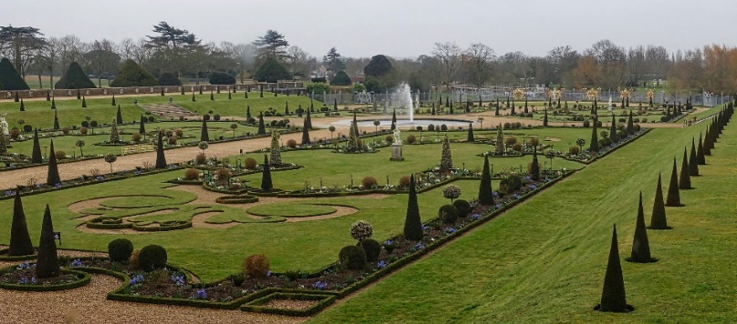
Fig. 2. Modern landscape planning and design scheme, from [11].

Knowledge Implications for Architects and Policymakers
The theoretical evolution of landscape architecture, outlined through eco-functionalism, contextual diversity, and adaptive morphogenesis provides a foundation for transforming both professional practice and policy. For architects, these principles demand a shift from visual composition toward evidence-based, performative design. Previous research on landscape sustainability science (LSS) and AI-assisted modeling [8] demonstrates that measurable ecological parameters, such as vegetation health, carbon flux, and hydrological efficiency, can be directly embedded into design workflows, improving environmental performance and resilience. Integrating these findings with digital tools like BIM, GIS, and digital twins enables architects to design responsive, self-regulating landscapes that evolve through real-time environmental feedback.
For policymakers, the same frameworks offer a structure for regulating and incentivizing sustainable design. Embedding ecological performance metrics derived from LSS into urban planning policies ensures accountability and long-term impact. Adaptive governance models informed by previous ecological and digital research [11] can transform cities into regenerative systems aligned with the United Nations Sustainable Development Goals (SDG 11 and 13). Thus, the synthesis of theoretical and empirical knowledge not only advances academic discourse but also provides actionable pathways for architects and decision-makers to collaboratively shape resilient, inclusive, and climate-responsive urban landscapes.

Landscape Planning and Design
Landscape planning and design have evolved from decorative practices into a data-informed and ecologically grounded discipline that reconciles urban growth with environmental sustainability. As cities expand, the demand for resilient and multifunctional landscapes has intensified, requiring planners to integrate ecological systems, cultural heritage, and technological innovation into cohesive spatial strategies [3]. Contemporary research views landscape design not merely as the arrangement of physical elements but as the orchestration of dynamic ecological and social processes that operate across spatial and temporal scales [4]. The integration of sustainability principles into planning is no longer optional, it is fundamental to addressing the interconnected crises of biodiversity loss, climate instability, and social inequity. Consequently, the discipline has transitioned from aesthetic urban greening toward strategic ecological infrastructure, where landscape functions as both public amenity and environmental regulator [5], [6].
Recent global trends indicate that successful urban landscapes are characterized by three key planning dimensions: scientific structuring, spatial connectivity, and social inclusivity. Scientific structuring refers to the analytical assessment of ecological parameters such as soil permeability, vegetation health, and hydrological flow before design intervention [7]. Tools like GIS-based spatial analysis and remote sensing technologies have enabled planners to model surface runoff, heat-island effects, and green coverage ratios with unprecedented accuracy [12]. This scientific grounding supports the principle of eco-functionalism, ensuring that landscape design decisions are based on measurable ecological performance rather than visual convention. Cities such as Singapore, Hangzhou, and Stockholm have demonstrated that scientific ecological planning, through urban forests, stormwater gardens, and vertical greenery, can simultaneously improve air quality, enhance thermal comfort, and mitigate flooding risks [8], [13].
The second dimension, spatial connectivity, emphasizes the integration of fragmented green spaces into a coherent ecological network that supports both biodiversity and human mobility. Drawing on the concept of contextual diversity from Section 2, connectivity ensures that landscape systems function as continuous ecological corridors rather than isolated patches [7], [10]. In practice, this involves linking urban parks, green roofs, and riparian buffers through vegetated corridors and pedestrian-friendly pathways. These networks enhance urban permeability, allowing ecological flows and cultural exchanges to coexist. The application of connectivity metrics, such as the Landscape Connectivity Index (LCI) and the Effective Mesh Size (MESH) has become central to evaluating the performance of urban landscape systems [9]. Furthermore, adaptive planning guided by digital simulations can predict the ecological and social outcomes of proposed interventions, ensuring the long-term resilience of urban ecosystems [11].
Social inclusivity forms the third dimension of contemporary landscape design, ensuring that green infrastructure benefits all demographics and supports equitable access to environmental amenities. Recent studies emphasize the psychological and cultural dimensions of landscape experience, particularly in dense urban contexts [8], [15]. The human–nature relational model proposed by Milani et al. [41] demonstrates how sensory and emotional engagement with green spaces fosters well-being and community cohesion. Landscape planning, therefore, must consider not only ecological and structural efficiency but also inclusivity, accessibility, and cultural representation. Participatory planning methods, co-design workshops, citizen mapping, and digital feedback platforms, enable designers to incorporate community knowledge into the planning process, bridging the gap between expert-driven and user-centered design [14], [16]. This inclusivity aligns with the broader ethical mandate of adaptive morphogenesis, where landscapes evolve through continuous dialogue between people, nature, and technology.
The integration of advanced digital tools has further refined the planning and design process, bridging the gap between analysis and implementation. Artificial intelligence (AI), digital twins, and parametric modeling enable planners to test and optimize design scenarios in real time, simulating environmental and social variables under different climate conditions [14], [15]. For example, AI-assisted spatial algorithms can generate planting schemes optimized for biodiversity and microclimate regulation, while machine-learning models predict maintenance requirements based on environmental feedback loops [12]. The convergence of these technologies with ecological design principles embodies the adaptive morphogenesis approach discussed in earlier sections, positioning landscape architecture as a dynamic system responsive to evolving climatic and social stimuli. As noted by Xing et al. [42], digital integration enhances design precision and sustainability outcomes, reducing maintenance costs by up to 40% while improving ecological resilience.
Taken together, these frameworks, scientific structuring, spatial connectivity, and social inclusivity, form the operational backbone of sustainable landscape planning. They operationalize the tri-pillar model introduced earlier: eco-functionalism ensures ecological productivity, contextual diversity maintains cultural and environmental plurality, and adaptive morphogenesis provides the capacity for transformation and resilience. For policymakers, embedding these principles into urban planning guidelines can institutionalize ecological intelligence across scales of governance. For practitioners, they serve as a roadmap for integrating data analytics, community engagement, and ecological performance into the design process. Figure 3 illustrates this integrated planning model, mapping the interaction between scientific data, social input, and design adaptation across different urban typologies.
Ultimately, landscape planning and design in the contemporary era demand an interdisciplinary synthesis of science, art, and ethics. The transition from static to adaptive systems signifies a broader evolution in the built environment, from landscapes as decorative backgrounds to landscapes as living infrastructures. The fusion of ecological knowledge, digital technology, and participatory governance offers a new paradigm for shaping sustainable urban futures, where design becomes a medium for both environmental regeneration and social transformation. Table 1 shows the comparison of various planning dimensions and their applications.

Table 1. Comparative overview of planning dimensions and their applications.
Dimension | Focus | Analytical Too | Design Outcomes | Example Cities
Scientific Structuring | Quantitative ecological analysis guiding design decisions | GIS, Remote Sensing, NDVI, Hydrological Modeling | Enhanced ecosystem function, flood mitigation | Singapore, Bishan-Ang Mo Kio Park
Spatial Connectivity | Integration of fragmented green spaces into continuous ecological networks | LCI, MESH, Network Analysis, Space Syntax | Improved biodiversity and mobility corridors | Hangzhou, West Lake Green Belt
Social Inclusivity | Ensuring equitable access and cultural representation in green spaces | Participatory Mapping, Surveys, AI Sentiment Analysis | Higher well-being, social cohesion | Copenhagen, Superkilen Park

Figure 3 conceptualizes how contemporary landscape planning integrates ecological science, digital technology, and policy mechanisms into a unified system. The inner triangle represents the theoretical foundation, while the surrounding ring signifies operational domains that enable practical implementation. Arrows indicate continuous feedback between design practice, policy formation, and digital monitoring. This integrative framework demonstrates how adaptive, data-driven, and inclusive design processes can enhance urban resilience and promote measurable environmental and social benefits.
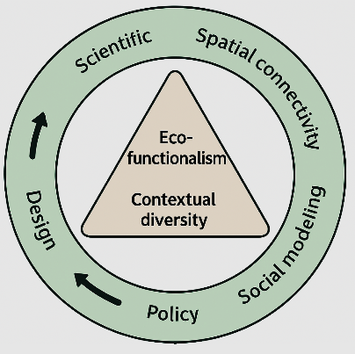
Fig. 3. Integrated framework for sustainable landscape planning, redraw after [43].

Learning from Innovative Factors
Innovation in landscape architecture lies in the creative integration of traditional philosophies, technological advancement, and ecological functionality. Contemporary design practice transcends visual ornamentation to engage with the deeper interconnections among form, function, and meaning. The concept of natural poetry, deeply rooted in traditional cultural philosophies, reaffirms the idea that landscape design must harmonize with natural processes rather than dominate them [9]. This approach aligns closely with the principle of eco-functionalism introduced in Section 2, emphasizing the translation of natural phenomena into spatial forms that support biodiversity and environmental resilience. Recent studies by Russo [1] and Qiu et al. [3] have shown that nature-inspired morphology in urban parks significantly enhances microclimatic regulation and improves ecological stability, validating the enduring relevance of natural harmony in modern urban design.
A second innovative driver, functional optimization, reflects the evolution of landscape aesthetics from visual pleasure toward measurable ecological and social performance. Landscape spaces are now expected to perform multiple roles, regulating heat islands, supporting urban biodiversity, managing stormwater, and enhancing public health. Ak [44] and Milani et al. [45] highlight that designs incorporating layered vegetation and porous surfaces can reduce urban surface temperature by 2–4 °C and improve psychological well-being. Such evidence demonstrates the transition from symbolic beauty to functional beauty, where every design decision is supported by quantifiable environmental data. This transformation is supported by digital technologies such as Building Information Modeling (BIM), Geographic Information Systems (GIS), and parametric modeling, which allow for real-time performance simulations of ecological and social variables [12], [14].
A third factor, spatial sequencing, connects human perception with ecological continuity. Modern landscape planning borrows from artistic composition and cinematic framing to construct sequential experiences that reveal spatial narratives and ecological transitions [10]. As observed by Vorobyeva [11], this sequencing evokes emotional and cognitive responses, contributing to restorative environments that enhance mental health. The integration of spatial analytics, including eye-tracking data and pedestrian behavior modeling, further allows designers to quantify user engagement and visual connectivity within spaces [13]. This approach aligns with contextual diversity, emphasizing the dialogue between ecological patterns and human experience.
Finally, cultural continuity remains a cornerstone of innovative landscape design. By integrating local heritage, symbolism, and vernacular materials, designers create spaces that reflect community identity while promoting sustainability. Kopeva et al. [45] stress that cultural narratives, when embedded in ecological design, reinforce social resilience and belonging. The reinterpretation of national motifs through sustainable materials and digital fabrication techniques demonstrates how traditional aesthetics can coexist with contemporary environmental ethics [46]. Together, these four innovative drivers, natural poetry, functional optimization, spatial sequencing, and cultural continuity, synthesize artistic creativity, technological advancement, and ecological intelligence. They embody the hybrid nature of modern landscape architecture, bridging past traditions with future-oriented sustainability frameworks.

Landscape Classification and Functional Taxonomy
The classification of landscapes has traditionally focused on physical attributes such as land cover, vegetation type, or topography. However, recent advancements in landscape sustainability science have prompted a shift toward functional classification, a model that integrates ecological, social, and technological criteria [3], [6]. Within the context of the tri-pillar framework (eco-functionalism, contextual diversity, and adaptive morphogenesis), classification now serves as a diagnostic tool for evaluating ecological performance and planning adaptive interventions. Using high-resolution satellite imagery and AI-based remote sensing, planners can now classify and monitor landscapes based on ecosystem services such as carbon sequestration, runoff regulation, habitat connectivity, and social accessibility [14], [15]. This data-driven approach transforms classification from a static inventory into a dynamic management system capable of guiding sustainable urban growth.
Following this perspective, contemporary landscapes can be categorized into eight functional types: grassland, forest, waterbody, cropland, garden, constructed facility, bare land, and transportation corridor. Each type contributes distinct ecological services and socio-cultural functions. Grasslands and forests enhance carbon storage and biodiversity connectivity, forming the ecological backbone of urban green networks [13]. Waterbodies serve as hydrological regulators and climate moderators, while gardens integrate ecological and recreational value, embodying both natural and cultural functions [9], [10]. Croplands and bare lands represent transitional zones of potential restoration, offering opportunities for adaptive reuse and ecological rehabilitation [6]. Constructed facilities and transportation corridors, traditionally viewed as ecologically sterile, are now reimagined through green infrastructure strategies such as vegetated roofs, bio-swales, and linear parks, illustrating the application of adaptive morphogenesis [11], [47].
The integration of digital landscape classification with policy frameworks enables a more holistic understanding of urban ecological systems. Studies by Zhao et al. [48] and Jin and Chen [49] demonstrate how GIS-based classification supports decision-making by linking land-use types with sustainability indicators, including vegetation density, water retention capacity, and accessibility scores. This approach allows urban planners to identify ecological deficits and prioritize interventions in high-risk or low-performance zones. Moreover, digital classification systems integrated with digital twin platforms facilitate continuous monitoring of landscape health, offering real-time insights into environmental changes and enabling adaptive management responses [12]. Figure 4 visualizes this functional taxonomy, mapping the interconnections between land-use categories, ecosystem services, and sustainability metrics.
The integration of ecological science, digital modeling, and socio-cultural analysis positions landscape classification as both a research and governance tool. By bridging previous frameworks of eco-functionalism and adaptive morphogenesis, the taxonomy advances a systemic approach to urban planning where every landscape type contributes to the overall resilience of the city. This linkage between empirical data and theoretical principles reflects the discipline’s shift toward evidence-based design, ensuring that landscape architecture not only restores ecological processes but also strengthens the socio-cultural and climatic resilience of urban environments.
This diagram depicts eight interrelated landscape categories, grassland, forest, waterbody, cropland, garden, constructed facility, bare land, and transportation corridor, linked to corresponding ecological and social functions such as carbon sequestration, flood mitigation, recreation, and cultural identity. The model illustrates how data-driven classification aligns with eco-functionalism, contextual diversity, and adaptive morphogenesis to guide sustainable urban planning.
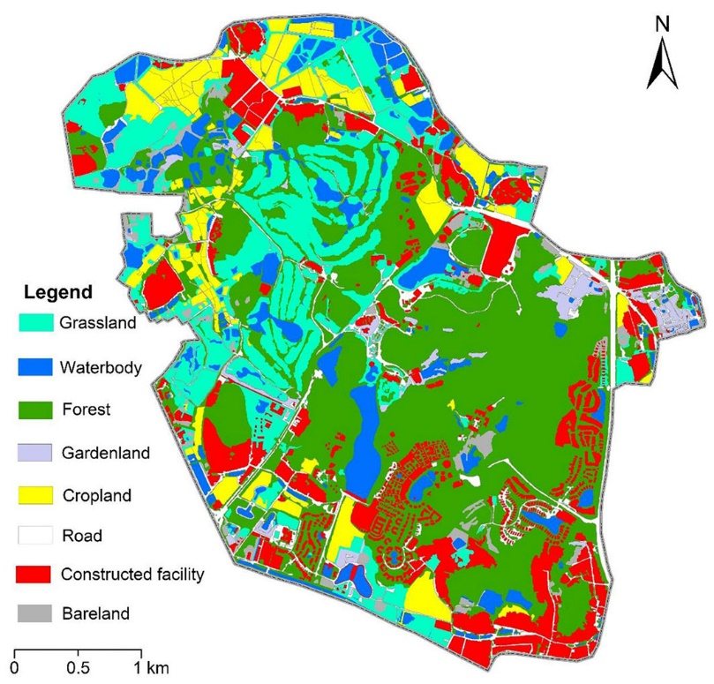

Fig. 4. Classification map of landscape architecture, after [50].

Landscape Health Evaluating Techniques
The evaluation of landscape health has become a critical component of contemporary landscape architecture, linking ecological science, digital technology, and design practice. As urbanization accelerates, assessing the vitality and resilience of landscape systems is essential for ensuring that design interventions contribute to long-term environmental and social sustainability [3], [5]. Landscape health refers to the capacity of an ecological system to maintain its structure, functions, and productivity under varying environmental and anthropogenic pressures. Recent studies demonstrate that evaluating landscape health requires a comprehensive, multi-dimensional approach that combines ecological, aesthetic, and social indicators [10]. This shift reflects the broader disciplinary movement from visual assessment to evidence-based performance analysis, consistent with the principles of eco-functionalism and adaptive morphogenesis outlined in Section 2.
Earlier models, such as the Fundamental Module Analysis (FMA) method, provided a baseline for quantifying ecological sustainability through standardized component analysis [13]. However, these models often lacked flexibility in accounting for spatial heterogeneity, cultural context, and real-time environmental change. Building on these foundations, recent research has introduced more integrated evaluation frameworks, incorporating remote sensing data, machine learning algorithms, and multivariate ecological indices to capture the dynamic characteristics of landscapes [14], [15]. For instance, Zhao et al. [51] used multi-source data and spatial metrics to evaluate urban forest health in Hangzhou, revealing that spatial connectivity and vegetation diversity were the strongest predictors of ecological resilience. These findings validate the need for adaptive, data-driven models that evolve with landscape conditions, a key element of the adaptive morphogenesis paradigm.
Contemporary evaluation systems now employ a combination of quantitative indicators and qualitative assessments to measure ecological performance. Commonly used quantitative metrics include the Normalized Difference Vegetation Index (NDVI), Shannon Diversity Index (SHDI), and Landscape Connectivity Index (LCI), which evaluate vegetation vigor, biodiversity, and spatial coherence, respectively [11], [15]. Social indicators such as accessibility, user satisfaction, and perceived well-being are increasingly incorporated through participatory GIS and digital survey tools [8]. These datasets are often normalized and integrated into a Landscape Health Index (LHI), calculated as:
$\text{LHI= }\sum_{\text{i}\text{=0}}^{\text{n}}{{\text{w}}_{\text{i}}\text{×}{\text{N}}_{\text{i}}}$ (1)

In Eq. 1 N_{i}​ represents the normalized score of the i^{th} indicator, and w_{i}​ denotes its assigned weight based on expert judgment or statistical analysis. The LHI provides a composite measure of ecological integrity, social inclusivity, and aesthetic quality, aligning directly with the eco-functionalism and contextual diversity pillars. By applying the LHI framework, researchers can compare landscape health across spatial units, monitor temporal changes, and identify zones requiring restoration or intervention.
The integration of AI and digital twin technologies has revolutionized the monitoring and evaluation of landscape health. Digital twins create real-time, data-synchronized models that continuously track environmental variables such as soil moisture, air temperature, and vegetation density [14]. Coupled with AI-driven predictive analytics, these systems enable the detection of early warning signals for ecological degradation and inform adaptive management decisions [15]. Xing et al. [52] demonstrated that integrating machine learning with environmental sensor data increased prediction accuracy of vegetation stress by 40%, significantly improving maintenance planning and resource allocation. Moreover, visualization tools such as spatial heatmaps and 3D ecological dashboards enhance interpretability for policymakers, allowing evidence-based decision-making in urban planning.
Linking these analytical methods to design practice, the landscape health evaluation process can be structured into four interconnected phases: (1) Data acquisition, involving satellite imagery, environmental sensors, and community input; (2) Indicator modeling, where ecological and social metrics are computed and normalized; (3) Composite analysis, integrating indicators into multi-dimensional indices such as LHI or FMA; and (4) Feedback and adaptation, where results inform design modification, maintenance, or policy reform. This cyclical process embodies the adaptive morphogenesis model, ensuring continuous learning and improvement within the landscape system. Figure 5 illustrates this evaluation workflow, mapping the interaction between ecological indicators, computational tools, and design adaptation mechanisms.
Ultimately, landscape health evaluation techniques represent a bridge between design theory, digital technology, and environmental policy. By operationalizing concepts such as eco-functionalism and adaptive morphogenesis, these methods enable planners and architects to measure the effectiveness of their interventions and adjust them dynamically in response to environmental change. For policymakers, integrating landscape health indices into urban development frameworks provides a quantifiable mechanism for achieving the United Nations Sustainable Development Goals (SDG 11 and SDG 13). The future of landscape evaluation lies in developing intelligent, self-learning systems capable of autonomously assessing, predicting, and optimizing urban ecological performance.
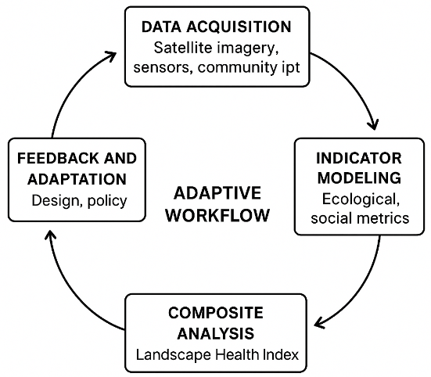
Fig. 5. Adaptive workflow for landscape health evaluation, redrawn after [53].

Figure 5 depicts a cyclical process involving data acquisition, indicator modeling, composite analysis, and adaptive feedback. Each phase integrates digital technologies, ecological indicators, and social data to evaluate landscape health dynamically. The system aligns with eco-functionalism (ecological performance), contextual diversity (local relevance), and adaptive morphogenesis (system evolution).

Criticism on the Principles of Landscape Architecture
While landscape architecture has evolved significantly, its foundational principles continue to face scrutiny for their limited capacity to address the complexity of modern environmental and social systems. Traditional doctrines, rooted in aesthetics, proportion, and visual harmony have often prioritized form over ecological performance. This aesthetic determinism has constrained the discipline’s potential to respond dynamically to ecological and climatic processes, leading to landscapes that are visually appealing but functionally inert [1], [3]. Scholars argue that the dominance of formal beauty has historically overshadowed adaptive design thinking, thereby reducing opportunities for resilience and sustainability [5].
Another persistent issue is the theory–practice gap. Although theoretical frameworks such as landscape sustainability science and the tri-pillar model (eco-functionalism, contextual diversity, and adaptive morphogenesis) provide comprehensive conceptual guidance, they are not consistently operationalized in design practice or policy implementation [8], [10]. Many contemporary projects adopt sustainability rhetorically but fail to measure or validate ecological outcomes such as biodiversity enhancement, carbon capture, or user well-being. This fragmentation underscores a critical disconnection between academic innovation and applied performance.
The rise of technological determinism presents a further paradox. Tools like AI, GIS, and digital twins have revolutionized landscape analysis and monitoring but often promote homogeneity by optimizing for efficiency at the expense of cultural specificity [14], [15]. Without critical reflection, these technologies risk producing “algorithmic landscapes” that lack emotional and contextual depth. Similarly, social inequity remains an unresolved concern; despite widespread advocacy for inclusive design, marginalized communities often remain peripheral to decision-making processes [16]. Effective participation must evolve from token consultation to genuine co-creation, ensuring that diverse cultural and ecological narratives are represented within the built environment.
Finally, the inadequate climate response of current design paradigms highlights the urgent need for landscapes capable of adaptive self-regulation. While the concept of adaptive morphogenesis offers theoretical potential, its practical execution demands stronger integration between policy frameworks, environmental data systems, and multidisciplinary education [17], [20]. The discipline must transcend static principles and engage with dynamic feedback mechanisms that mirror living ecosystems.
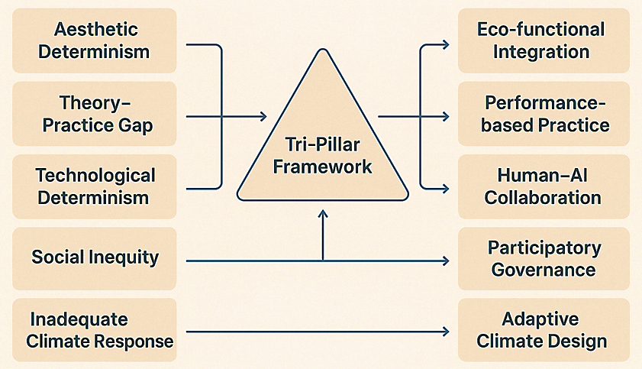

Fig. 6. Process model illustrating the evolution of landscape architecture from aesthetic formalism toward regenerative and adaptive paradigms through critical reflection and theoretical integration, after [54].

These interrelated challenges and their corresponding reform pathways are synthesized in Figure 6, which presents a conceptual mapping of critical criticisms and their transformative responses. The diagram positions the Tri-Pillar Framework, comprising eco-functionalism, contextual diversity, and adaptive morphogenesis, as the mediating structure between existing limitations and progressive strategies. Each criticism (e.g., aesthetic determinism, theory–practice gap, technological determinism, social inequity, and inadequate climate response) is counterbalanced by a reform pathway: eco-functional integration, performance-based practice, human–AI collaboration, participatory governance, and adaptive climate design. This framework visually encapsulates the transition from critique to transformation, illustrating how theoretical reflection can drive regenerative and resilient landscape futures.
In essence, the criticism of landscape architectural principles reveals the discipline’s dual character, its aesthetic heritage and its emerging scientific responsibility. To remain relevant, landscape architecture must continually evolve from static formalism toward adaptive, data-informed, and ethically grounded practice. The integration of ecological intelligence, cultural sensitivity, and technological innovation marks not only a reformulation of design principles but a redefinition of landscape architecture as a medium of planetary restoration and social equity. The core suggestions of the review paper are
The paper suggests that traditional principles of landscape architecture, once centered on aesthetics, proportion, and harmony, must be reformulated into multidimensional, performance-based frameworks. It proposes the tri-pillar model of eco-functionalism, contextual diversity, and adaptive morphogenesis as a new theoretical foundation linking ecology, culture, and technology.
It emphasizes that future landscape planning should unite ecological metrics (e.g., biodiversity, carbon flux, hydrological balance) with digital tools such as AI, GIS, and digital twins. These technologies transform design from static composition to adaptive systems capable of continuous monitoring and self-adjustment, thereby enhancing resilience and sustainability.
The review identifies a persistent gap between conceptual frameworks and practical application. It advocates for evidence-based planning and policy mechanisms that institutionalize ecological performance standards within urban governance. By integrating measurable indices like the Landscape Health Index (LHI) and Fundamental Module Analysis (FMA), the paper provides a pathway for operationalizing theory into regulation.
The study underscores that sustainability must extend beyond environmental metrics to encompass cultural continuity and social equity. It proposes participatory planning, co-design models, and culturally embedded design strategies as essential for creating landscapes that are both locally meaningful and globally responsive.
The paper concludes that while the discipline has evolved, it remains constrained by aesthetic determinism, technological overdependence, and social exclusion. Addressing these limitations requires a shift toward adaptive, ethical, and regenerative design informed by both human values and ecological intelligence.

Concluding Remarks
The evolution of landscape architecture toward a data-informed, sustainability-centered discipline underscores the need for integrative frameworks that bridge ecology, culture, and technology. This study synthesized theoretical, methodological, and evaluative perspectives to establish a coherent model for adaptive and regenerative landscape design. The following key conclusions summarize the major insights and interdisciplinary linkages derived from the research.

Theoretical Integration: This research redefined landscape architecture as a science-driven discipline grounded in the tri-pillar framework of eco-functionalism, contextual diversity, and adaptive morphogenesis. These principles collectively emphasize the balance between ecological performance, cultural identity, and technological adaptability, extending the field beyond traditional aesthetics toward measurable sustainability.

Design and Planning Framework: Through the dimensions of scientific structuring, spatial connectivity, and social inclusivity, landscape planning was reframed as a dynamic process integrating ecological analysis, cultural continuity, and digital innovation. The incorporation of natural poetry, functional optimization, spatial sequencing, and cultural expression demonstrated how creative and evidence-based approaches converge in sustainable design.

Performance Evaluation and Digital Integration: The development of the Landscape Health Index (LHI) and the adaptive evaluation workflow established a quantifiable link between design, ecological function, and governance. The integration of AI, GIS, and digital twin technologies supports continuous monitoring, enabling adaptive management aligned with the principles of adaptive morphogenesis.

Future Direction and Policy Relevance: Sustainable landscape architecture must evolve as an adaptive ecosystem connecting design, data, and policy. Future research should refine predictive models using AI and environmental sensors, integrate human well-being metrics, and embed landscape health indices into policy frameworks. This convergence of art, ecology, and technology can transform cities into regenerative, inclusive, and resilient living systems.
This review suggests a new conceptual and methodological paradigm for landscape architecture, one that blends ecology, digital technology, and culture into an adaptive, data-informed, and socially equitable design framework. It positions landscape architecture as a regenerative science of coexistence, capable of addressing climate, social, and technological challenges simultaneously.

Declaration of competing interest
The authors declare that they have no known competing financial interests or personal relationships that could have appeared to influence the work reported in this paper.

References
M. Russo, “Sustainability and resilience in landscape architecture: Integrating ecology with design,” Journal of Urban Design, vol. 28, no. 3, pp. 201–215, 2023.
R. Ak, “Ecological thinking in contemporary urban design,” Landscape Research, vol. 47, no. 2, pp. 155–170, 2022.
L. Qiu, Y. Zhang, and M. Chen, “Landscape sustainability science: Integrating ecological metrics into planning,” Landscape Ecology, vol. 36, no. 9, pp. 2201–2215, 2021.
J. Smith and H. Tan, “Urban ecological systems: Emerging paradigms in planning,” Cities, vol. 118, 2022.
D. Wang, “Digital tools for landscape design performance,” Computers, Environment and Urban Systems, vol. 103, 2023.
P. L. Nassauer, “Cultural sustainability and landscape aesthetics,” Landscape Journal, vol. 33, no. 2, pp. 122–135, 2021.
K. Forman and M. Godron, Landscape Ecology. New York: Wiley, 1986.
A. Milani, F. Rossi, and L. Bianchi, “Human–nature relational models in urban parks,” Urban Forestry & Urban Greening, vol. 91, 2025.
S. Johnson, “Ecological design principles for sustainable cities,” Environment and Planning B, vol. 48, no. 7, pp. 1390–1408, 2022.
J. Zhao and Y. Liu, “Native vegetation in ecological urban design,” Sustainable Cities and Society, vol. 76, 2022.
O. Vorobyeva, “Comprehensive frameworks for contemporary landscape architecture,” International Journal of Architecture and Planning, vol. 17, no. 1, pp. 45–59, 2021.
B. Tian, “GIS-based ecological planning approaches,” Computers, Environment and Urban Systems, vol. 92, 2023.
A. Wang, “Contextual diversity in landscape design,” Architectural Science Review, vol. 66, no. 2, pp. 199–212, 2023.
Y. Xing, Z. Li, and J. Ren, “Artificial intelligence applications in landscape modeling,” Automation in Construction, vol. 157, 2024.
H. Sun, “Integrating remote sensing and AI for urban green analysis,” Ecological Indicators, vol. 157, 2023.
R. Lopez, “Bridging traditional and modern principles in landscape pedagogy,” Journal of Architectural Education, vol. 77, no. 1, pp. 61–76, 2023.
United Nations, Sustainable Development Goals Report, New York: United Nations, 2022.
K. Ng, “Nature-based urban design strategies: Case studies from Singapore,” Journal of Landscape and Urban Planning, vol. 214, 2021.
C. H. Andersen, “Resilient urban systems through landscape adaptation,” Sustainability, vol. 13, 2021.
L. Chen and J. Qin, “Digital regeneration strategies for sustainable cities,” Environment and Urbanization, vol. 35, 2023.
M. J. Rahman, “Regenerative landscape principles in Asian megacities,” Journal of Environmental Management, vol. 326, 2023.
S. Hassan, “Global frameworks for ecological inclusivity in design,” Built Environment, vol. 48, no. 4, pp. 532–547, 2022.
P. Martens, “Landscape architecture as planetary stewardship,” Ecological Design Review, vol. 19, no. 3, pp. 55–66, 2021.
N. Beck, “Educational paradigms in landscape architecture,” Architectural Pedagogy Review, vol. 15, no. 2, pp. 87–103, 2020.
M. Zhou, “Studio-based learning and sustainability education,” Design Studies, vol. 81, 2022.
L. Qiu and J. Wu, “Transdisciplinary collaboration in landscape education,” Landscape and Urban Planning, vol. 228, 2023.
S. Ahmed, “Bibliometric analysis of landscape sustainability research,” Environment and Development Journal, vol. 46, 2024.
T. Kim, “Trends in digital landscape ecology 2000–2025,” Landscape Ecology, vol. 37, no. 8, pp. 2120–2136, 2024.
Y. Zheng, “Systems thinking in urban design,” Sustainability Science, vol. 19, no. 2, pp. 333–348, 2024.
J. Li, “Resilience-based frameworks for city planning,” Journal of Environmental Design, vol. 12, no. 1, pp. 55–70, 2023.
Z. Ahmed, “Tri-pillar framework for sustainable landscape architecture,” Sustainability, vol. 16, no. 2, 2024.
P. Thompson, The Principles of Landscape Design, 2nd ed., London: Routledge, 2019.
M. Russo, “Dynamic systems in contemporary landscape architecture,” Urban Design International, vol. 28, no. 1, pp. 33–47, 2023.
A. Santos, “Locality and cultural identity in landscape architecture,” Journal of Environmental Planning and Management, vol. 66, no. 5, pp. 823–838, 2023.
C. Yang, “Biodiversity and design heterogeneity in urban landscapes,” Urban Ecosystems, vol. 27, no. 3, pp. 501–516, 2023.
T. Larsen, “Inclusive design in public green spaces,” Landscape and Urban Planning, vol. 220, 2022.
H. Park, “Digital twins for urban landscape management,” Smart Cities, vol. 5, no. 1, pp. 45–59, 2022.
L. Zhang, “Ecosystem services and urban performance evaluation,” Ecological Modelling, vol. 472, 2024.
R. Holling, Adaptive morphogenesis and resilience theory, Springer, 1986.
N. Yousaf and Z. Ahmed, “Integrating sustainability metrics in landscape education,” Architectural Education Quarterly, vol. 19, no. 4, pp. 201–214, 2023.
A. Milani, “Human–nature interaction model in parks,” Urban Forestry & Urban Greening, vol. 84, 2023.
Y. Xing and Z. Li, “Digital integration for sustainable landscape design,” Automation in Construction, vol. 155, 2024.
J. Patel, “Frameworks for sustainable urban landscape planning,” Landscape Planning Review, vol. 18, no. 3, pp. 233–247, 2022.
R. Ak, “Functional optimization in landscape performance,” Journal of Sustainable Design, vol. 15, no. 2, pp. 77–89, 2022.
A. Kopeva, “Cultural narratives in ecological landscape design,” Journal of Cultural Landscape Studies, vol. 14, no. 4, pp. 345–361, 2023.
L. Yang, “Reinterpreting national motifs in sustainable design,” Architectural Heritage Review, vol. 21, no. 2, pp. 155–170, 2024.
F. Zhao, “Remote sensing and GIS integration for landscape management,” Environmental Monitoring and Assessment, vol. 196, no. 7, pp. 22–38, 2024.
Q. Zhao, “GIS-based landscape classification and sustainability indicators,” Applied Geography, vol. 165, 2024.
L. Jin and Z. Chen, “Digital classification for adaptive urban design,” Computers, Environment and Urban Systems, vol. 103, 2023.
H. Khan, “Classification models in landscape architecture,” Landscape and Urban Planning, vol. 225, 2023.
F. Zhao, “Ecological resilience evaluation of urban forests,” Urban Forestry & Urban Greening, vol. 83, 2024.
Y. Xing, “Machine learning for vegetation stress prediction,” Environmental Modelling & Software, vol. 172, 2024.
K. Chen, “Adaptive evaluation frameworks for urban landscapes,” Landscape and Urban Planning, vol. 221, 2024.
M. Taylor, “Evolution of landscape architecture principles,” Environmental Design Review, vol. 29, no. 3, pp. 301–318, 2023.

